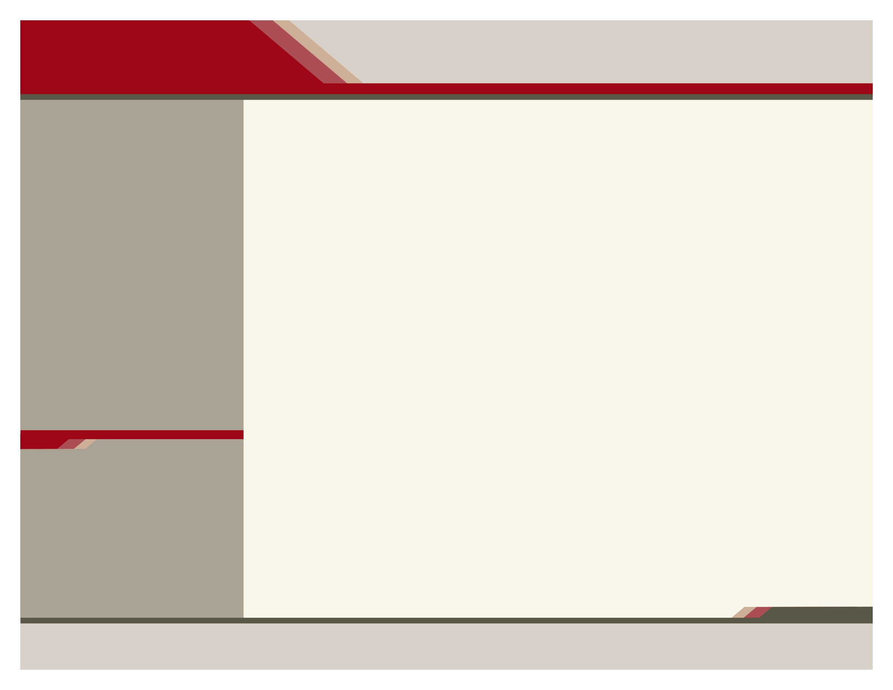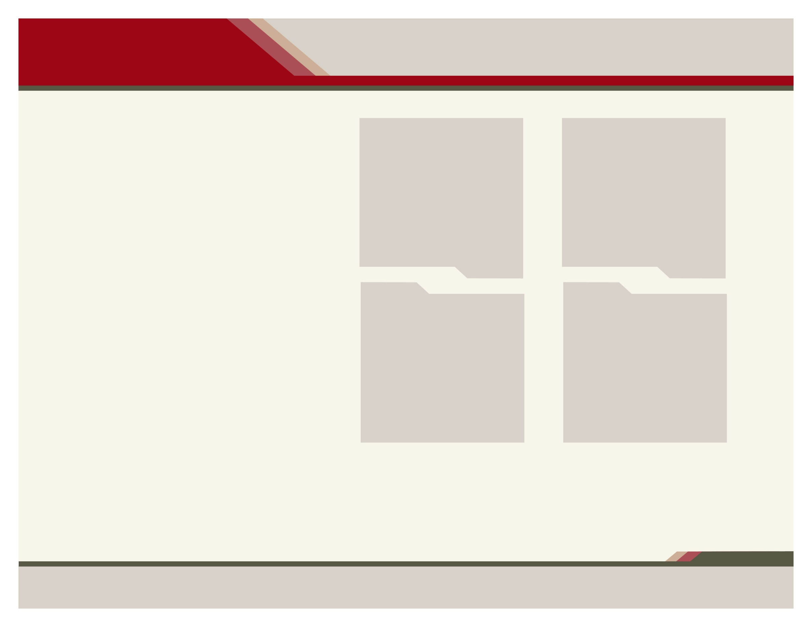

chetn.org 

**On-Site Services**

* PRIMARY CARE
* SICKNESS CARE
* MANAGEMENT OF ILLNESS
* PHYSICALS
* GYNECOLOGICAL EXAMS
* FAA-AVIATION PHYSICALS
* IMMUNIZATIONS/SHOTS
* LABORATORY
* X-RAY
* HEALTH EDUCATORS
* MEDICATION ASSISTANCE
* BLACK LUNG HELP
* TELEHEALTH
* OFF-SITE LIMITED DENTAL
* BEHAVIORAL/MENTAL HEALTH
* PEDIATRICS
* NON-ENGLISH TRANSLATION
* ENDOCRINOLOGY
* 340B CONTRACT PHARMACY
* RETINAL EYE EXAMS

***Dr. John Burrell***

***Dr. Curtis Sexton***

***Dr. Safwan Hamwi***

***Dr. Jeffrey Mann***

***Mary Morris, CFNP***

***April Bryant, MSN,FNP-C UT Facu. Stephanie Conder,DNP,FNP-BC***

***Teresa Rasmussen, PA-C***

***Emily Tamer, PA-C***

***Gerald Osborn, DO***

***William Evan Wilson, PMHNP-BC***

***Amber Harris, LPC-MHSP***

***Andrew Follett, MA***

OPEN: MONDAY – FRIDAY WITH EXTENDED OFFICE HOURS OF 8:00 A.M. TO 8:00 P.M.

iNSURANCE

ACCEPTING: MEDICARE • TENNCARE •Commercial Plans Licensed in Tennessee • UNINSURED • SELF-PAY • MEDICARE ADVANTAGE PLANS • SLIDING FEE SCALE OF SERVICES AVAILABLE TO UNINSURED/UNDERINSURED based on Household Size and Household Income (ask staff for more information)

APPOINTMENTS

**cALL (423) 562-1705 TO SCHEDULE AN APPOINTMENT**

*Empowering individuals and families*

*to improve their quality of life*

*An Equal Opportunity Employer*

*Title VI: CHET does not discriminate based upon age, gender, race, color, religion or national origin.*

oFFICE HOURS

NOW ACCEPTING NEW PATIENTS - INFANTS, CHILDREN, ADOLESANTS, ADULTS AND GERIATRICS

Community Health

of East TENNESSEE, Inc.

Clinic

A federally qualified health center

ACCEPTING NEW PATIENTS



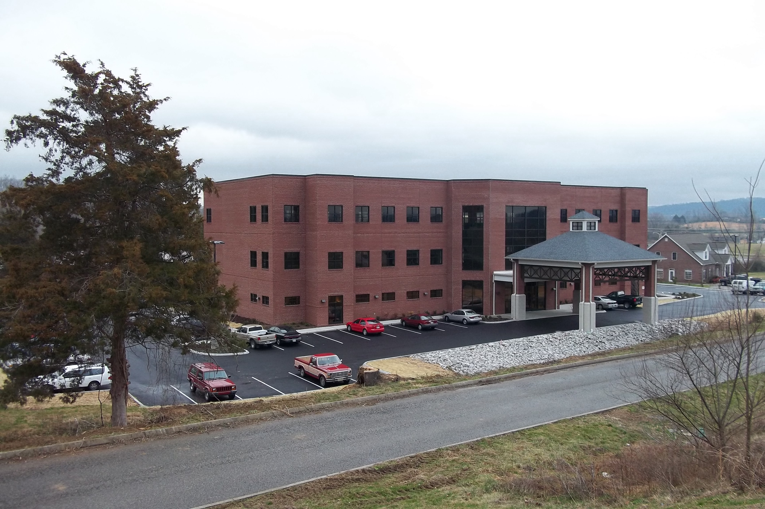

| 130 Independence LN, LaFollette, TN 37766 | phone 423.562.1705 | fax 423.566.3718

BEHIND cvs pHARMACY

**What is a medical home**? 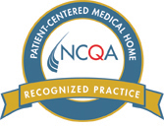

It’s an approach to providing comprehensive primary care that facilitates partnership between individual patients and their personal providers, and when appropriate, the patient’s family.

A variety of studies have demonstrated that medical homes improve access and reduce unnecessary medical costs.

The Medical Home is an innovative, team-based approach to providing health care services. A partnership develops between the patient, his or her primary clinician, and a health care team. Together, following evidence-based guidelines for medical care, the team will coordinate to provide the best health care services possible for you.

You are the key to meeting your healthcare goals. You are able to take control of your health.

The doctor/practitioner will treat your health problems and will lead your health care. They will also coordinate your care with other doctors.

Your health care team will focus on you as a whole person, not just your illness. Your team will talk to you about ways to avoid getting sick in the future and stay health.

chetn.org

**Please notify our office 24 hours prior to your scheduled visit to cancel. Failure to do so may result in discharge from practice or scheduling privileges**

**Please arrive early for your appointment to allow for paperwork**

**For continuity of care, please inform your physician or nurse if you have been seen by another physician or have had changes in your medication**

**Medications sent Electronically to Pharmacy**

**At each visit bring:**

* **Current list of Medicines**
* **Picture I.D.**
* **Insurance Cards**
* **Co-payments**
* **Sliding Fee - Must show proof of Income Annually**

A Look Good Feel Better Site ; American Cancer Society

**During office hours call (423) 562-1705**

**After hours and weekends call (423) 562-1705 TeamHealth Nurse Line**

**Electronic Access available - PATIENT PORTAL**

Enter Contact Information Here | 1127 Lombard Blvd. San Francisco, CA 59802 | phone 555.555.5555 | fax 555.555.5555

Enter Contact Information Here | 1127 Lombard Blvd. San Francisco, CA 59802 | phone 555.555.5555 | fax 555.555.5555

| 130 Independence LN, LaFollette, TN 37766 | phone 423.562.1705 | fax 423.566.3718

Delete text box or place a tagline or quote here to callout something from your text here. Delete text box or place a tagline or quote here to callout something from your text here. Delete text box or place a tagline or quote here.

.

**Visits**

Facilitating Patient-Centered Medical home recognition for NCQA

– a new approach to improve your healthcare

**Access**

**quality**

**Other**

Community Health of East TN, Inc. Clinic

A federally qualified health center